**Module 7 – Assignment**

**Problem Statement:**

As a Data Analyst for AdventureWorks, you are investigating the use of live connections to Azure SQL Database and Azure SQL Data Warehouse.

In this assignment, you will create a Power BI Desktop report and use DirectQuery to pull data from the AdventureWorks database hosted in Azure. You will then publish this report to Power BI Service.

**You have been asked to:**

h) Publish the report to Power BI Service

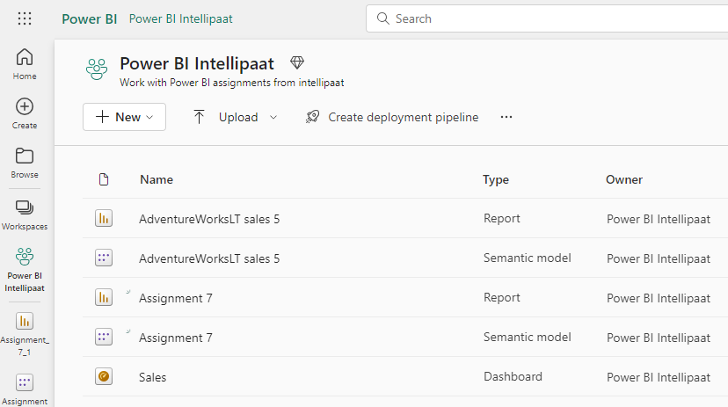

i)Open the Assignment 7 report, and create a card visual with a LineTotal field

